***SKAGIT parameter summary 7/14/2015***

SSURGO data was used where available in the Skagit (WA657, WA661, WA673, WA749, WA774), else parameters were derived from STATSGO data (gsmsoil_WA). There are 8425 unique soils polygons in the Skagit and 244 unique map units with both spatial and tabular data available. A map unit is a soil configuration with multiple components and horizons. For each map unit, the soil properties are depth averaged for all horizons and spatiallly averaged for all soil components to estimate unique parameters for each map unit.

Access database sequel processing: see C:/skagit/SSURGOsoils/soildb_Skagit.mdb

Multiple spatial and depth weighting queries are linked to final ouput: ToExport

The 2011 NLCD Dataset was downloaded and compared to the soil depth. In DHSVM, the rooting depth can not exceed the soil depth; for this reason, the soil depth was limited to 0.25-2.25 m deep based on the SSURGO soil depth of 0.08 – 2.25 m, based on a minimum rooted depth of evergreen trees estimated to be 0.25.

**DHSVM soils parameters**

***Lateral conductivity (K)***

lateral saturated hydraulic conductivity for surface soil type i in m/s (float).

Source: SSURGO data in chorizon table **ksat_r**. Surface horizon K in spatial average for each map unit.

Skagit SSURGO range with Aniostropic ratio =0.5: 0.5-50 cm/hr

Skagit SSURGO range with Aniostropic ratio =1: [0.000003, 0.0003] m/s ~ 1-100 cm/hr

Skagit SSURGO range with Aniostropic ratio =2: 2-200 cm/hr

Median (A=1)=0.000009 m/s; 3.24 cm/hr; 32.4 mm/hr

Kelleher et al. 2015 range: [0.0001 0.01] m/s ; Source: Limited information, kept wide.

Skagit STATSGO range: [Silty Loam/Loam/Sandy Clay/Loam/SandyClay/Clay=0.00002; Loamy Sand=0.0003; Sand 0.001; Bedrock =2] m/s

***Capillary drive***

The estimated volumetric soil water content at or near zero bar tension, expressed as a percentage of the whole soil.

Source: SSURGO data = chorizon table column **wsatiated_r**

Skagit SSURGO parameter range: [0.003, 0.67] median=0.28

Kelleher et al. 2015 range: [0.03 0.6]; Source: Morel-Seytoux and Nimmo [1999]

***Exponential decrease f***

Exponent for change of lateral conductivity with depth for soil type i (float). This was estimated using Kmin=Kmean e ^ -fd. The mean K is the spatial and depth average value. Large decreases in shallow soils were limited to f=5. No decrease in shallow soils were set to f=1, assuming a linear decrease.

Source: SSURGO data (K and Depth) in chorizon table.

Skagit parameter range: [0.1, 5]. Median f = 0.8 Mean f =1.4

Kelleher et al. 2015 range: [0.05 5]; Source: No description of method

Skagit STATSGO range: [Silty Loam/Loam/Sandy Clay/Loam/SandyClay/Clay/Loamy Sand/ f=1; Sand/Bedrock =2] m/s

Figure X. Resulting exponential decrease of surface saturated hydraulic conductivity with depth in selected soil SSURGO map units.

Blue: f=0.9; d=1.339, Kmin=0.00002 m/s; surface average K = 0.0003 m/s

Red: f=1.6; d=0.0002; Kmin=0.000034 m/s; surface average K=0.000036 m/s

***Maximum infiltration i***

maximum infiltration rate for soil type i in m/s (float)

Maximum values of K occuring in a mapunit were extracted. Source data in chorizon table.

Skagit SSURGO range: [0.00003, 0.0003] m/s ~ 10-100 cm/hr

Kelleher et al. 2015 range: [0.000036, 0.000538]; Source: Akan [1993]

***Surface albedo i***

surface albedo of soil type i in m/s (float).

Source data in component table was spatially averaged for each map unit.

Skagit SSURGO range: [0.017,0.44]. Median = 0.23

Kelleher et al. 2015 range: [0.2, 0.3]; Source: Dingman [2002]

Skagit STATSGO range: All soils =0.1

***Number of soil layers i***

number of soil layers for soil type i (integer)

All soil layers use the same value since soil horizon data is only available for each component, which is spatially averaged to estimate a value for each map unit.

***Porosity i***

porosity of soil type i (0-1) (number of soil layer floats)

**Option 1:**

Total porosity was estimated using SSURGO bulk density available in the chorizon table column *dbovendry_r* where

Porosity = (1-(r b/r d) x 100 (particle density = 2.65 g/cm3)

The oven dry weight of the less than 2 mm soil material per unit volume of soil exclusive of the desication cracks, measured on a coated clod. Dimensions = grams per cubic centimeter.

Total porosity parameter range: [0.33,0.98]. Median = 0.51

Shallow soils with low Db (<200 g/cm3) result in high values.

See limitation that fieldc < porosity in DHSVM and therefore the need for

**Option 2:**

Effective porosity was estimated using the fraction of sand and clay in each map unit scaled between 100% sand effective porosity is 0.38 and 100% clay effective porosity is 0.06 (see soil textural triangle). The source of percent contributions of sand and clay is the chorizon table.

Effective porosity parameter range: [0.13,0.38].

Kelleher et al. 2015 range: [0.2, 0.3]; Source: CONUS, Miller and White [1998]

***Pore size distribution i***

pore size distribution index for soil type i (number of soil layer floats)

Sand % and % Clay weighted average where Sand = 0.592 and Clay =0.131. Rawls et al. [1982]

Skagit SSURGO range: [0.2, 0.58];

Kelleher et al. 2015 range: [0.07, 0.559]; Source: Rawls et al. [1982] Table 2

***Bubbling pressure i***

bubbling pressure for soil type i (integer)

Sand % and % Clay weighted average where Sand = 0.07 and Clay =0.37.

Source: Rawls et al. [1982] Table 2

Skagit SSURGO range: [0.08, 0.32];

Kelleher et al. 2015 range: [0, 1.24]; Source: Rawls et al. [1982]

***Field capacity i***

field capacity for soil type i (0 - porosity) (number of soil layer floats)

Field capacity = water contents at 1/10 or 1/3 bar = chorizon table column **wthirdbar_r**

Skagit parameter range: [0.003, 0.375] Median = 0.1

Kelleher et al. 2015 range: [0.15, 0.25]; Source: Saxton and Rawls [2006]

***Wilting point i***

wilting point for soil type i (0 - porosity) (number of soil layer floats)

Wilting point = 15 bars tension. = chorizon table column **wfifteenbar_r**

Skagit parameter range: [0.0007, 0.31] Median = 0.04

Kelleher et al. 2015 range: [0.07 0.15]; Source: Saxton and Rawls [2006]

***Bulk density i***

bulk density of soil type i in kg/m3 (number of soil layer floats)

Bulk density = chorizon table column = **dbovendry_r** =The oven dry weight of the less than 2 mm soil material per unit volume of soil exclusive of the desication cracks, measured on a coated clod. Dimensions = grams per cubic centimeter

Skagit parameter range: [56, 1764] median = 1297

Kelleher et al. 2015 range: [1390, 1650]; Source: Saxton and Rawls [2006]

***Vertical conductivity i***

vertical conductivity of soil type i in m/s (number of soil layer floats)

K_ave = ksat_r arithmetic depth average of horizons and spatially average components.

Skagit SSURGO range: [0.0000009, 0.0003] m/s ~ [0.3, 108] cm/hr Median=0.00002

Kelleher et al. 2015 range: [0.0000000001, 0.0002]; Source: Meyer et al. [1997]

***Thermal conductivity i***

thermal conductivity of dry soil type i in W/m°C (number of soil layer floats) based on %sand and clay content where Dry Clay =0.3 W/m C Dry Sand =0.8 W/m C

Skagit parameter range: [0.38, 0.78] Median 0.74

Kelleher et al. 2015 range: [0.3, 0.8]; Source: Abu-Hamdeh and Reeder [2000], Ochsner

et al. [2001]

***Thermal capacity i***

thermal capacity of soil type i in J/m3°C (number of soil layer floats) based on %sand and clay content.

Where Thermal Capacity MJ/m3/K

Sand 1.0;Loam 2.0;Clay 3.0

<http://www.engineeringtoolbox.com/sensible-heat-storage-d_1217.html>

Skagit parameter range: [1041527, 2681968] Median = 1208442

Kelleher et al. 2015 range: [1000000, 3000000]; Source: Ochsner

et al. [2001]

***Mannings n***

Skagit parameter range: [0.03, 0.1] Arcement and Schneider [1989] where soil depth greater than 0.1 m the Manning’s n was set to 0.03, else Mannings n was set to 0.1.

Kelleher et al. 2015 range: [0.11, 0.35]; Source: Sturm [2010]

**DHSVM vegetation parameters to review**

Maximum snow interception capacity: model default

Kelleher et al. 2015 range: [0.05 0.2] Source: Breuer et al. [2003], Cuo et al. [2011]

Mass release drip ratio: model default

Kelleher et al. 2015 range (model default): [0 1] Wigmosta et al. [199]

Snow interception efﬁciency: : model default

Kelleher et al. 2015 range (model default): [0 1]; Cuo et al. [2011]

Height Basin ALSM data 0 1.2

Maximum resistance Cuo et al. [2011], Land Data Assimilation

Systems (LDAS) [2013]

500 1000

27 Minimum resistance Rosenzweig and Abramopoulos[1997],

Zhou [2011], LDAS [2013]

100 175

28 Moisture threshold Meyer et al. [1997], Cuo et al. [2011] 0.115 0.165

29 Vapor pressure deﬁcit Fetcher [1976], Wigmosta et al. [1994] 200 4000

30 Rpc Chen [1996] 0.1 1

31 Root fraction, layer 1 Zeng [2001] 0.25 0.45

32 Root fraction, layer 2 Zeng [2001] 0.45 0.65

33 Monthly LAI LDAS [2013], Mitchell et al. [2004] 0.65 1.35

34 Monthly albedo LDAS [2013], Mitchell et al. [2004] 0.1 0.23

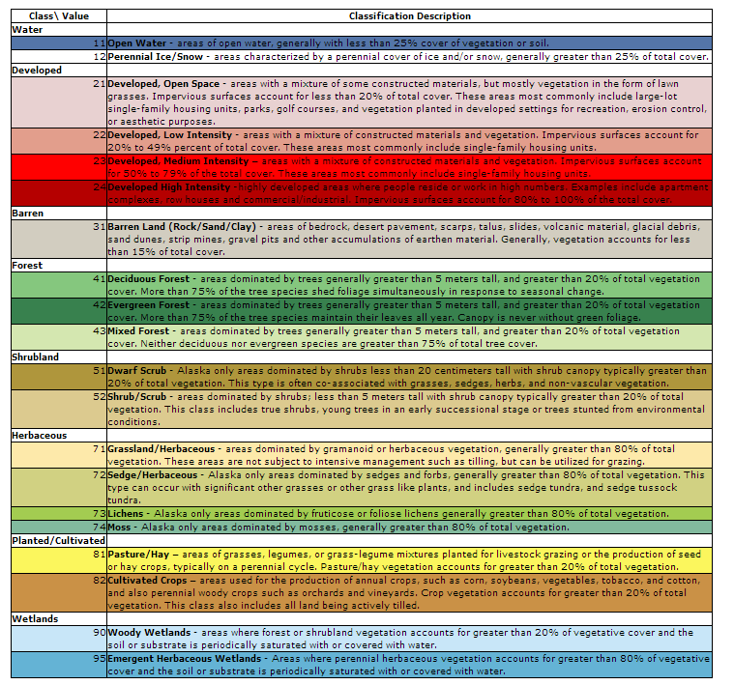

SSURGO tabular processing

1. Preliminary Step (after merge spatial data, import tabular data) Import Table: BasinMukeyList
2. Spatial component weights and albedo
3. Depth horizon average and other parameter values
4. Export compiled data
5. **Preliminary Step**

**Import Table: BasinMukeyList**

This can be generated from the SSURGO merged shapefile, exported attribute table. Add unique ID when prompted. Export the SSURGO merged clipped shapefile attribute table to a text. Open in Excel. Change the MUKEY format to ‘text’.

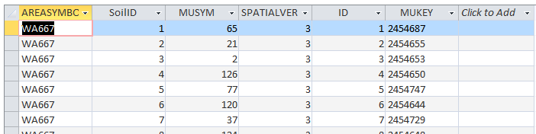

1. **Get component percent and albedo: weight1**

Link component and horizon tables to get the representative component percent for each component in each mapunit and the albedo for each component.

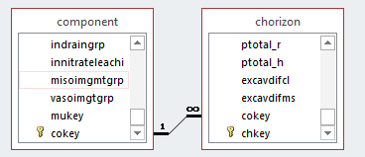

SELECT component.mukey, component.cokey, First(component.comppct_r) AS FirstOfcomppct_r, component.albedodry_r

FROM component INNER JOIN chorizon ON component.cokey = chorizon.cokey

GROUP BY component.mukey, component.cokey, component.albedodry_r;

**Get total component percent and albedo average: weight2**

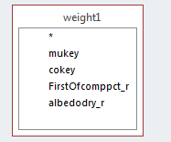

SELECT weight1.mukey, Sum(weight1.FirstOfcomppct_r) AS SumOfFirstOfcomppct_r, Avg(weight1.albedodry_r) AS AvgOfalbedodry_r

FROM weight1

GROUP BY weight1.mukey;

**Get component weights and albedo**

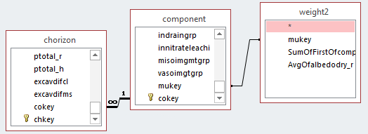

SELECT component.mukey, component.cokey, [comppct_r]/[SumOfFirstOfcomppct_r] AS weight, component.albedodry_r AS albedo

FROM (component INNER JOIN weight2 ON component.mukey = weight2.mukey) INNER JOIN chorizon ON component.cokey = chorizon.cokey

GROUP BY component.mukey, component.cokey, [comppct_r]/[SumOfFirstOfcomppct_r], component.albedodry_r;

1. **Depth average**

**3a. D_ave_1: get parameter values in each horizon**

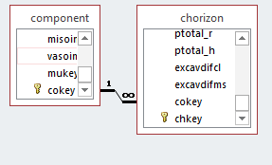

SELECT chorizon.chkey, Sum(([hzdepb_r]-[hzdept_r])) AS d, chorizon.ksat_r AS ksat, Max(chorizon.ksat_r) AS kmax, Min(chorizon.ksat_r) AS kmin, chorizon.awc_r AS awc, [wthirdbar_r]/100 AS fieldc, [wfifteenbar_r]/100 AS wiltp, [sandtotal_r]/100 AS Sand, [silttotal_r]/100 AS Silt, [claytotal_r]/100 AS Clay, [dbovendry_r]*1000 AS Db, [wsatiated_r]/100 AS CapDrive

FROM component INNER JOIN chorizon ON component.cokey = chorizon.cokey

GROUP BY chorizon.chkey, chorizon.ksat_r, chorizon.awc_r, [wthirdbar_r]/100, [wfifteenbar_r]/100, [sandtotal_r]/100, [silttotal_r]/100, [claytotal_r]/100, [dbovendry_r]*1000, [wsatiated_r]/100

HAVING (((chorizon.ksat_r) Is Not Null) AND ((Max(chorizon.ksat_r)) Is Not Null) AND ((Min(chorizon.ksat_r)) Is Not Null));

**3b. D_ave_2: Get parameter values and depth for each horizon in each component – example wilting point**

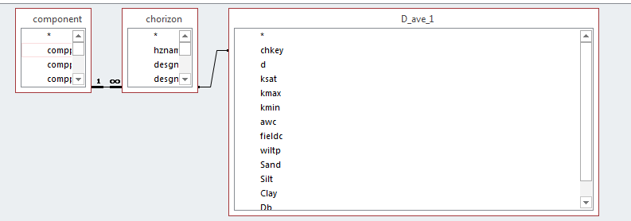

SELECT component.cokey, chorizon.chkey, D_ave_1.d, [wiltp]*[d] AS wiltpd

FROM component INNER JOIN (chorizon INNER JOIN D_ave_1 ON chorizon.chkey = D_ave_1.chkey) ON component.cokey = chorizon.cokey

GROUP BY component.cokey, chorizon.chkey, D_ave_1.d, [wiltp]*[d]

HAVING ((([wiltp]*[d]) Is Not Null));

**3c. D_ave_3: sum parameters in each component – example for wilting point**

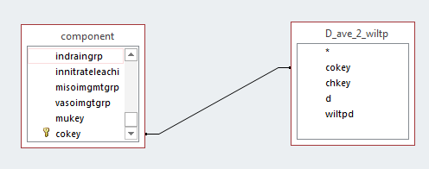

SELECT component.cokey, Sum(D_ave_2_wiltp.wiltpd) AS SumOfwiltpd

FROM component INNER JOIN D_ave_2_wiltp ON component.cokey = D_ave_2_wiltp.cokey

GROUP BY component.cokey;

**3d. D_ave_4: divide sum of horizons over depth by sum of depth**

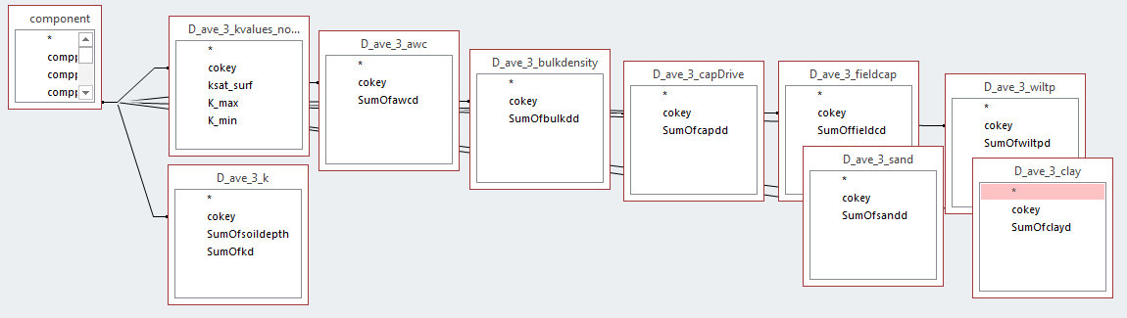

SELECT component.cokey, D_ave_3_kvalues_nodepthave.ksat_surf, D_ave_3_kvalues_nodepthave.K_max, D_ave_3_kvalues_nodepthave.K_min, [SumOfkd]/[sumofsoildepth] AS K_ave, [SumOfawcd]/[sumofsoildepth] AS AWC, [SumOfbulkdd]/[sumofsoildepth] AS BulkDensity, [SumOfcapdd]/[sumofsoildepth] AS CapDrive, [SumOffieldcd]/[sumofsoildepth] AS Fieldcap, [SumOfwiltpd]/[sumofsoildepth] AS Wiltp, [SumOfsandd]/[sumofsoildepth] AS SandPercent, [SumOfclayd]/[sumofsoildepth] AS ClayPercent

FROM ((((((((component INNER JOIN D_ave_3_k ON component.cokey = D_ave_3_k.cokey) INNER JOIN D_ave_3_awc ON component.cokey = D_ave_3_awc.cokey) INNER JOIN D_ave_3_bulkdensity ON component.cokey = D_ave_3_bulkdensity.cokey) INNER JOIN D_ave_3_capDrive ON component.cokey = D_ave_3_capDrive.cokey) INNER JOIN D_ave_3_fieldcap ON component.cokey = D_ave_3_fieldcap.cokey) INNER JOIN D_ave_3_wiltp ON component.cokey = D_ave_3_wiltp.cokey) INNER JOIN D_ave_3_sand ON component.cokey = D_ave_3_sand.cokey) INNER JOIN D_ave_3_clay ON component.cokey = D_ave_3_clay.cokey) INNER JOIN D_ave_3_kvalues_nodepthave ON component.cokey = D_ave_3_kvalues_nodepthave.cokey

GROUP BY component.cokey, D_ave_3_kvalues_nodepthave.ksat_surf, D_ave_3_kvalues_nodepthave.K_max, D_ave_3_kvalues_nodepthave.K_min, [SumOfkd]/[sumofsoildepth], [SumOfawcd]/[sumofsoildepth], [SumOfbulkdd]/[sumofsoildepth], [SumOfcapdd]/[sumofsoildepth], [SumOffieldcd]/[sumofsoildepth], [SumOfwiltpd]/[sumofsoildepth], [SumOfsandd]/[sumofsoildepth], [SumOfclayd]/[sumofsoildepth];

1. **Final Step: ToExport_MMDDYY**

Data from final depth averaging is linked to the component table unique ID, weighted by component, and linked to the mukey unique ID, so there is one final parameter value per mukey.

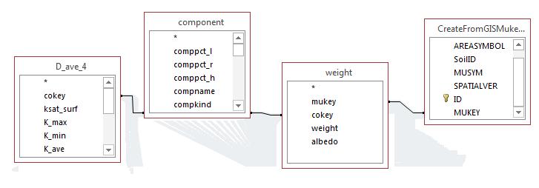

SELECT component.mukey, Sum([K_max]*[weight]/1000000) AS kmax_ms, Sum([k_min]*[weight]/1000000) AS kmin_ms, Sum([k_ave]*[weight]/1000000) AS Kave_ms, Sum([ksat_surf]*[weight]/1000000) AS Ksurf_ms, Sum([CapDrive]*[weight]) AS cappdriv, Sum([albedo]*[weight]) AS Alb, 1-((Sum([bulkdensity]*[weight])/2650)) AS Totalporosity, Sum([fieldcap]*[weight]) AS fieldc, Sum([wiltp]*[weight]) AS wiltpoint, Sum([fieldcap]*[weight]) AS db, Sum([sandpercent]*[weight]) AS sand, Sum([claypercent]*[weight]) AS clay, Sum([awc]*[weight]) AS awccap

FROM SkagitMukeyList INNER JOIN ((component INNER JOIN weight ON component.cokey = weight.cokey) INNER JOIN D_ave_4 ON component.cokey = D_ave_4.cokey) ON SkagitMukeyList.[Soil Description] = weight.mukey

GROUP BY component.mukey;

1. Export to Excel spreadsheet e.g. ToExport_Chehalis050516.xlsx
   1. Check data
      1. What is the range of Ksurf, max and min?
      2. What is the range of calculated DHSVM input parameters?
      3. Is wilting point less than field capacity?
      4. Is total porosity less than field capacity?

Totalporosity: 1-((Sum([bulkdensity]*[weight])/2650))

* + 1. What is the exponential decrease? f? Does it fit an exponential decrease?
  1. Calculate f

1. Convert to DHSVM input
   1. Convert to text file
   2. Run script
   3. Paste into soil section of DHSVM input